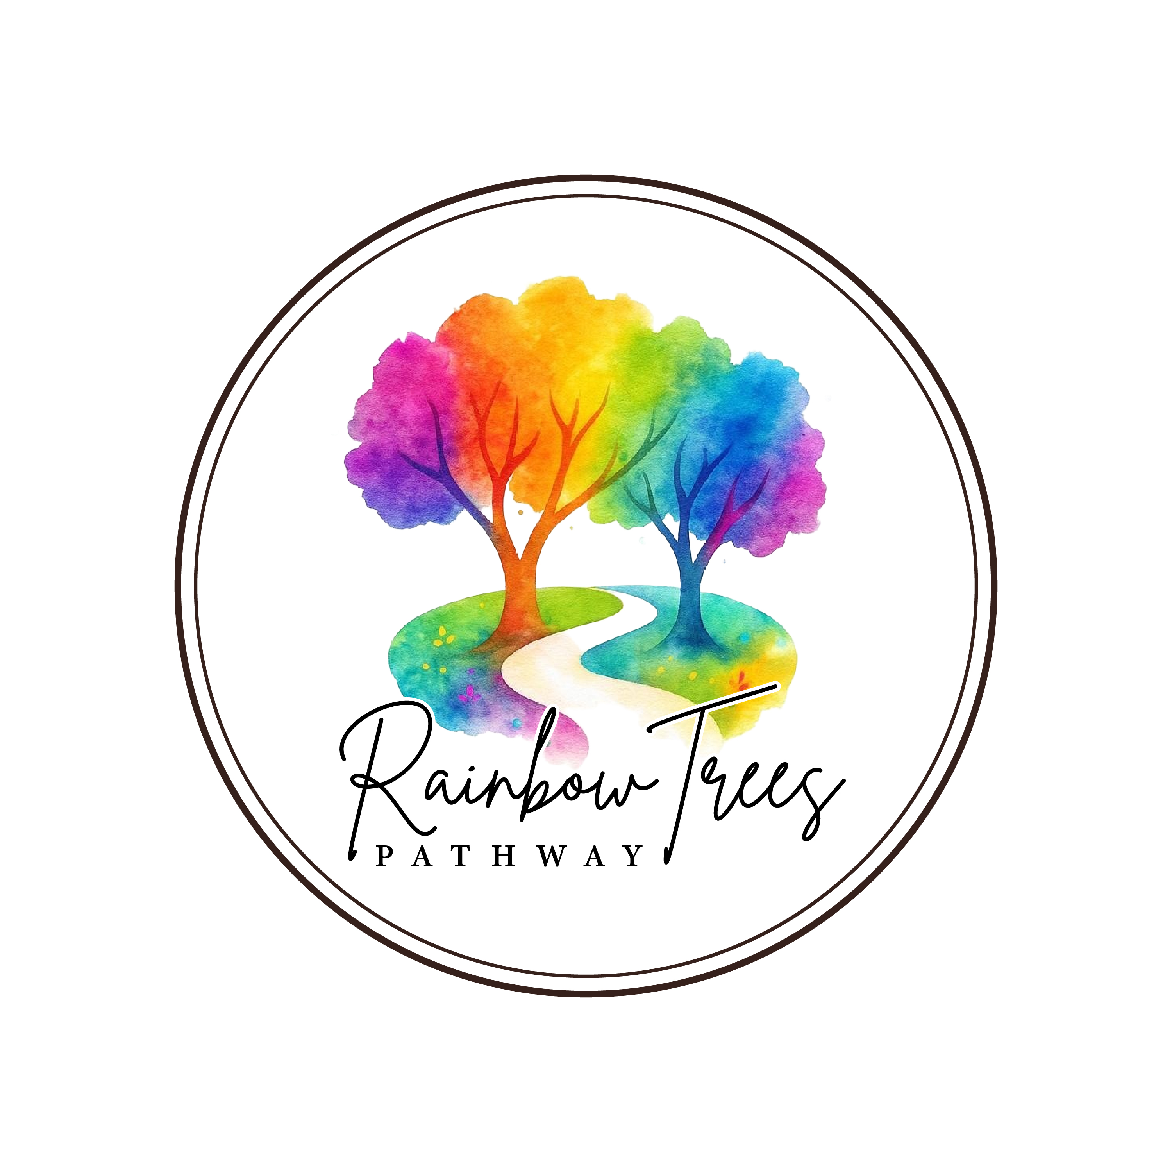

DATA PROTECTION COMPLAINT FORM

Organisation name: Rainbow Trees Pathway takes the protection of personal data seriously. If you believe we have not handled your personal data correctly, please complete this form so we can investigate and respond. We will acknowledge your complaint within 30 days of receipt.
SECTION 1 | YOUR DETAILS

Full Name:

Address (if relevant):

Email Address:

Telephone Number:

Preferred Method of Contact: | e.g. email / telephone

SECTION 2 | YOUR RELATIONSHIP WITH US

Please tick the option that best describes your relationship with us:
Employee | ☐ Former employee
☐ Job applicant | ☐ Customer / Client
☐ Supplier | ☐ Contractor
☐ Visitor | ☐ Other (please specify below)

If 'Other', please specify:

SECTION 3 | WHAT IS YOUR COMPLAINT ABOUT?

Please tick all that apply:
☐ My personal data is inaccurate | ☐ I have not received a response to my rights request
☐ My personal data has been shared without my permission | ☐ I believe my personal data has been used unlawfully
☐ I have concerns about how my personal data is being stored | ☐ I have received someone else's personal data
☐ I believe there has been a data breach | ☐ Marketing communications
☐ CCTV | ☐ Other (please specify below)

If 'Other', please specify:

SECTION 4 | DETAILS OF YOUR COMPLAINT

Please explain what happened and why you believe your personal data has been handled incorrectly. Include as much detail as possible.
Please write your complaint here...

SECTION 5 | RELEVANT DATES

When did the issue occur? | DD/MM/YYYY

When did you become aware of it? | DD/MM/YYYY

Have you previously raised this concern with us? | Yes / No

If yes, when and how?

SECTION 6 | PEOPLE INVOLVED

Please provide the name(s) of any employees or departments involved, if known.
Names / departments...

SECTION 7 | SUPPORTING EVIDENCE

Please attach any documents that may help us investigate. Examples include:
☐ Emails | ☐ Letters | ☐ Screenshots
☐ Photographs | ☐ Copies of correspondence | ☐ Reference numbers

List of documents attached (if any):

SECTION 8 | WHAT OUTCOME ARE YOU SEEKING?

Please tick all that apply:
☐ Correction of my personal data | ☐ Deletion of my personal data
☐ Access to my personal data | ☐ Restriction of processing
☐ Explanation of what happened | ☐ Apology
☐ Other (please specify below)

If 'Other', please specify:

SECTION 9 | ADDITIONAL INFORMATION

Please provide any other information you feel is relevant to your complaint.
Any other information...

SECTION 10 | DECLARATION

Declaration: I confirm that the information I have provided is accurate to the best of my knowledge. I understand that this complaint will be handled in accordance with the organisation's Data Protection Complaints Policy.

Signature:

Full Name:

Date: | DD/MM/YYYY

What Happens Next?
◆ We will acknowledge receipt of your complaint within 30 days.
◆ We will investigate your concerns without undue delay and keep you informed of our progress.
◆ We may contact you if we need further information to assist with our investigation.
◆ If you remain dissatisfied after we have responded, you may raise your concerns with the Information Commissioner's Office (ICO) at www.ico.org.uk or by calling 0303 123 1113.
.Please return this completed form to: Hello@rainbowtreespathway.co.uk

INTERNAL USE ONLY — NOT FOR DISTRIBUTION
Complete this section when the complaint is received. This page forms part of the organisation's audit trail.
Complaint Reference Number:

Date Received:

Received By (Name):

Assigned Investigator:

Date Acknowledged (must be within 30 days of receipt):

Acknowledgement Due Date:

Response Due Date:

Outcome:

Lessons Learned / Actions Taken:

Date Closed:

Disclaimer: This form is provided for general guidance purposes only and does not constitute legal advice. Organisations should ensure their complaint handling procedures comply with the Data (Use and Access) Act 2025, the UK GDPR, and the Data Protection Act 2018. It must not be copied, shared, distributed, or resold without prior written permission from Employment with Amy.

Document Review Record
Document Title
Review Date
Reviewed By (Name)
Reviewed By (Job Title)
Next Review Date
Reason for Review
Approved By
Version Number

